This media release is embargoed until 14 May, 10 a.m. CEST

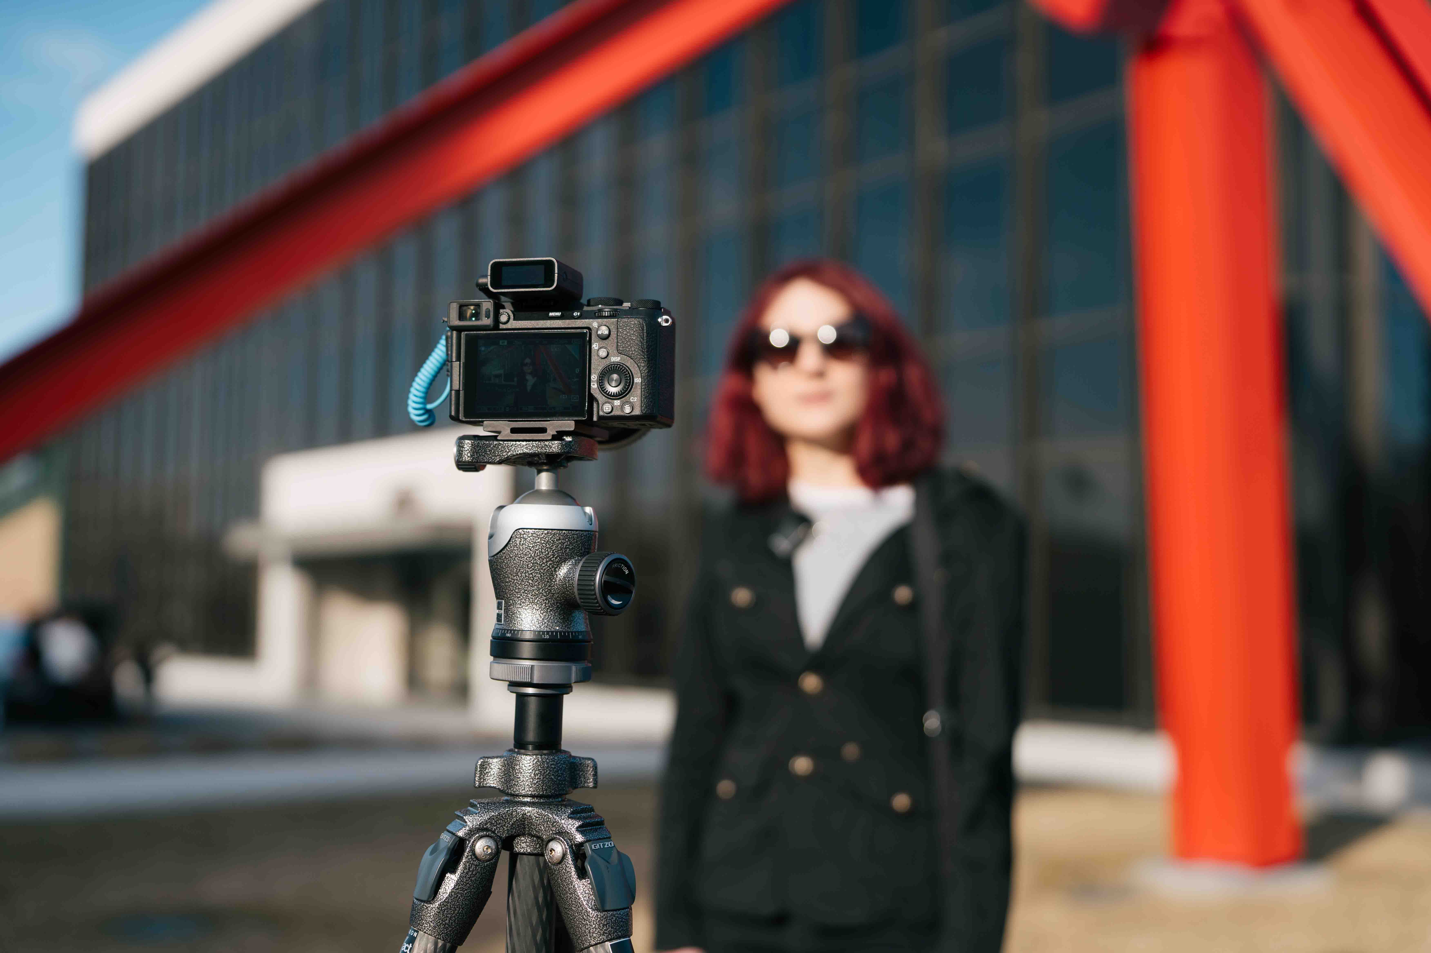

Sennheiser introduces Profile Wireless 1-channel mic and releases 32-bit float firmware update
New system caters to solo creators, while keeping users’ options for upgrading open

Wedemark, 14 May 2025 – Sennheiser today announced a one-channel version of its Profile Wireless 2.4 GHz all-in-one microphone solution. The streamlined single-mic system comes in a compact bag and includes a second USB charging cable instead of the charging bar of the two-channel version launched in late 2024. Designed to be lightweight and ultra-portable, the one-channel version covers typical usage scenarios of solo creators, while allowing for later expansion of the system by including the same two-channel receiver as the Profile Wireless 2-channel system. Also, a 32-bit float firmware update for all Profile Wireless systems is available for download on the Sennheiser website from today.

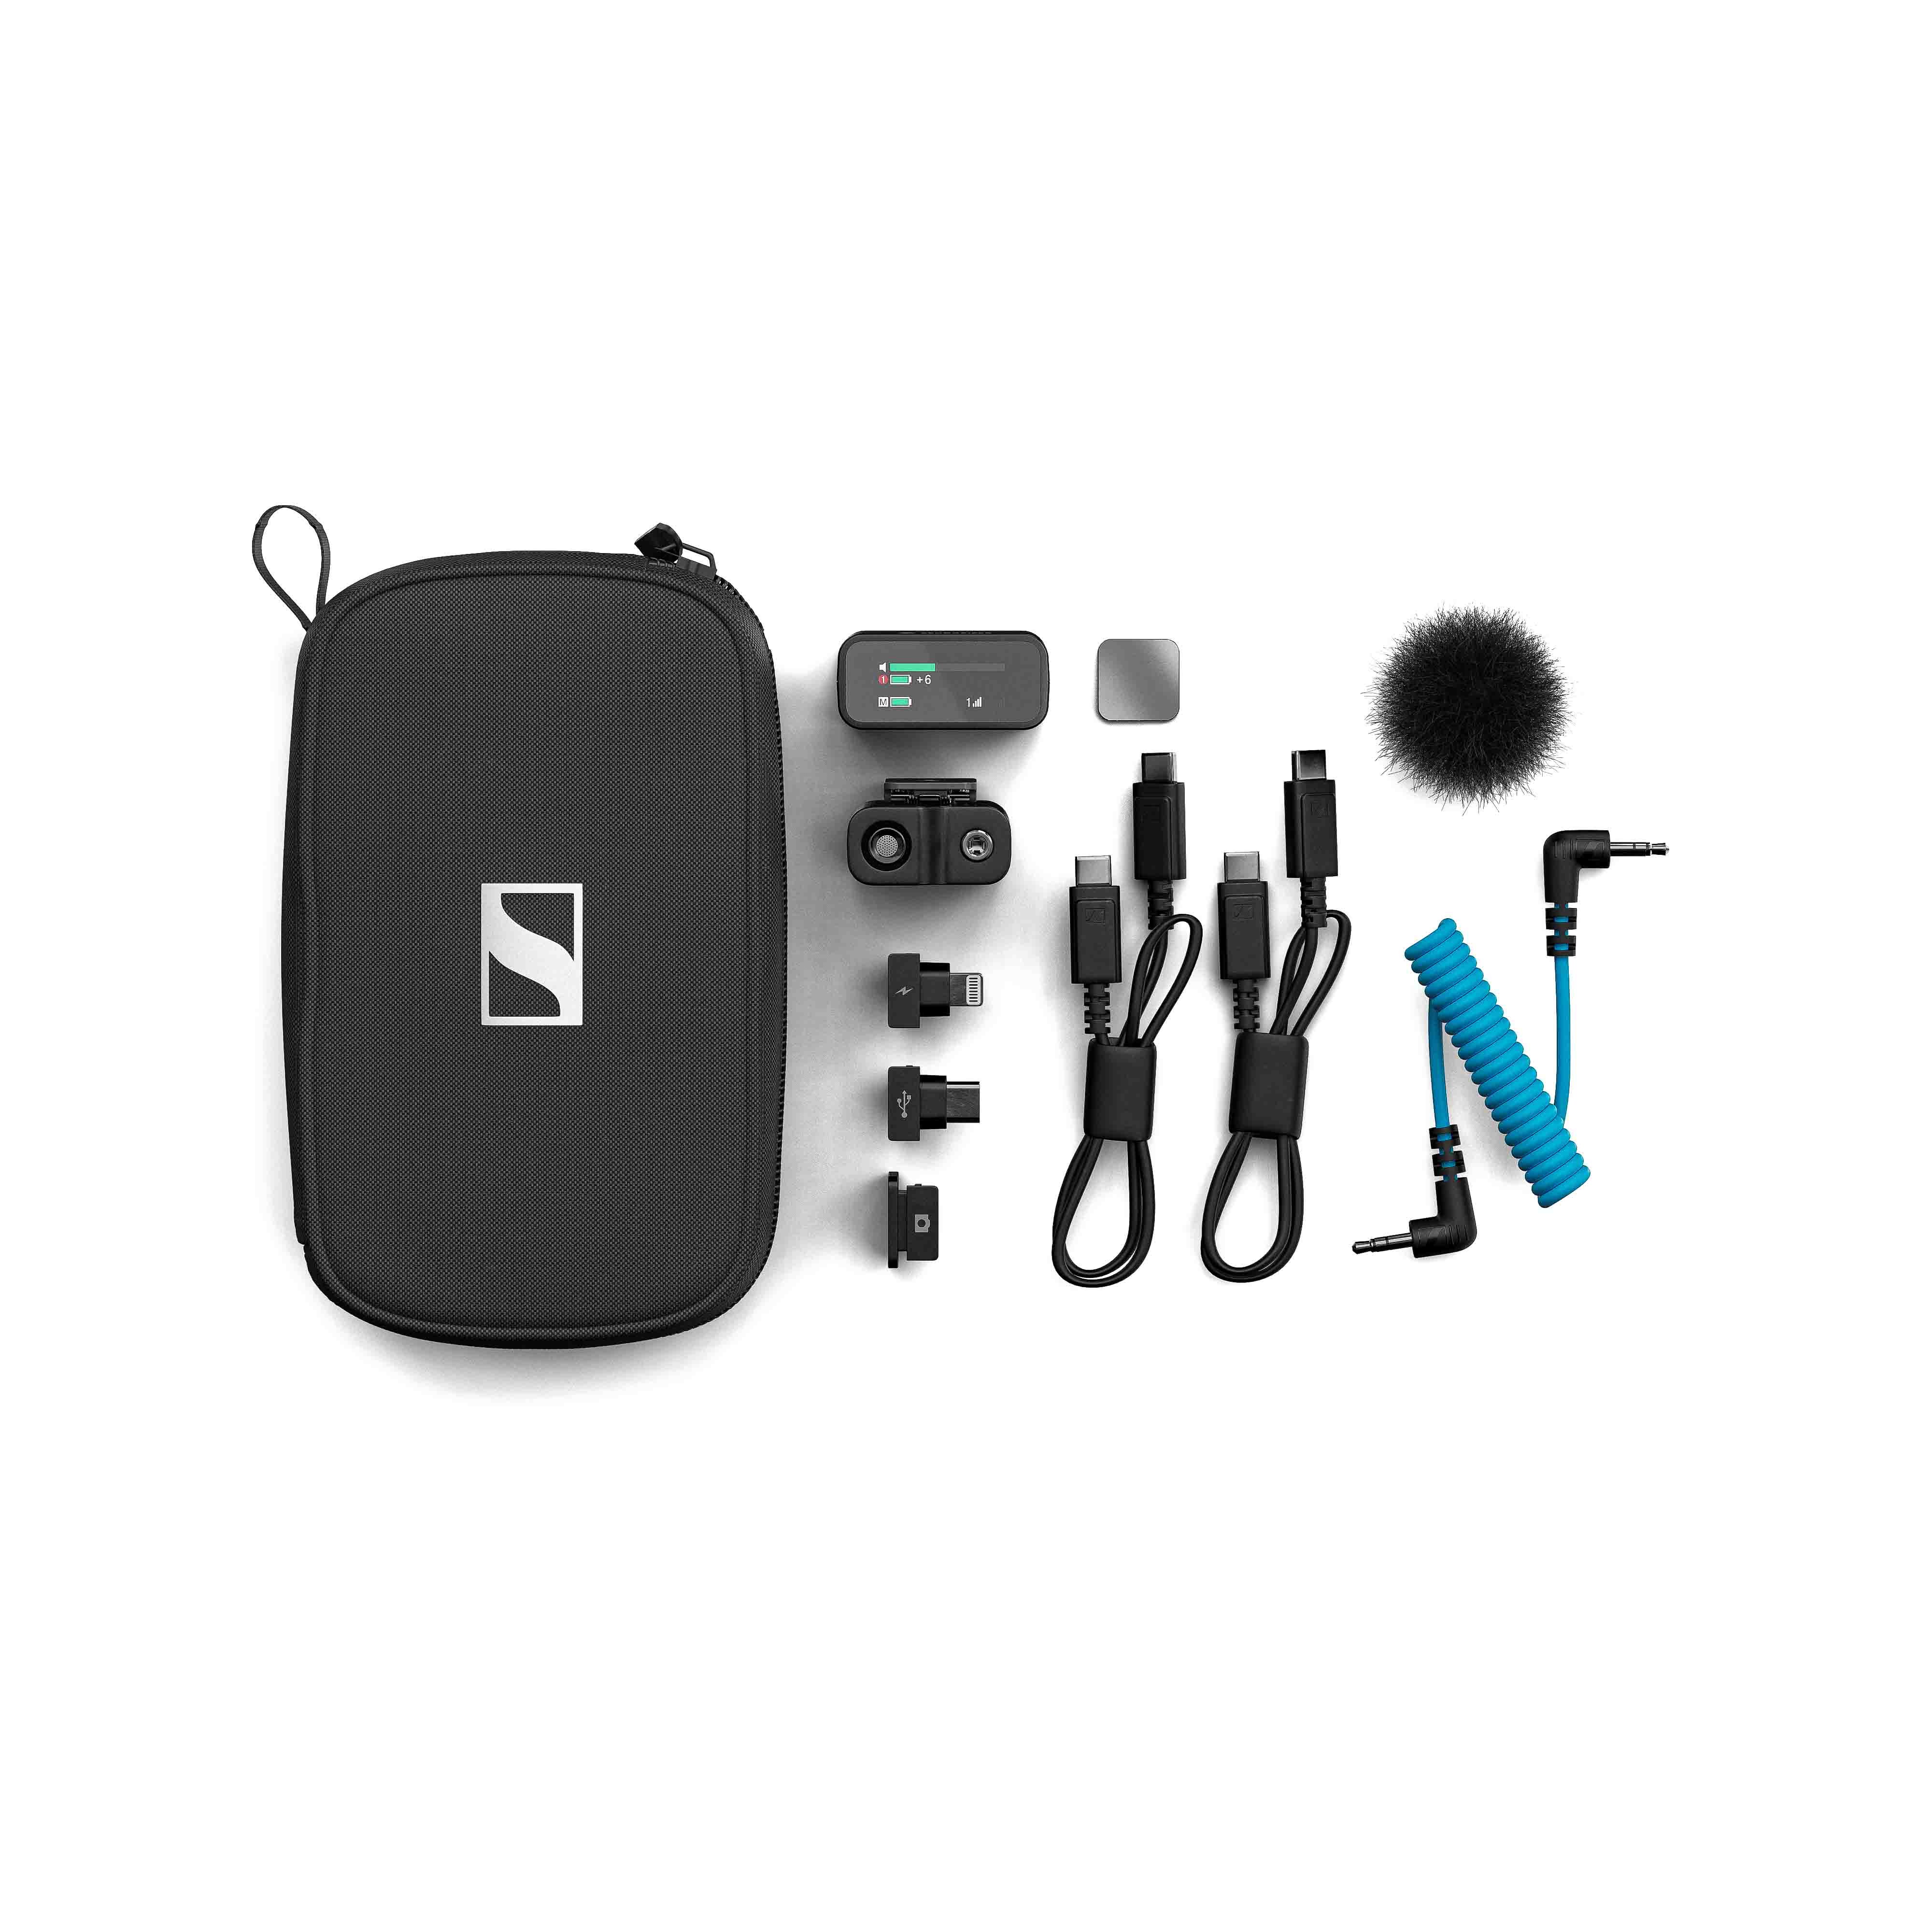 | The Profile Wireless 1-channel mic system includes a clip-on mic with mini windshield and magnetic mount, a two-channel receiver, two USB cables, USB-C and Lightning adapters, a camera cable and a shoe mount adapter

Streamlined one-channel version
“Following the huge success of the Profile Wireless 2-channel system, we’re now catering to the solo creator, who does not require the full two-channel package but would rather like to save on weight and cost and still have Sennheiser audio quality,” says Hendrik Millauer, Product Manager Broadcast & Film at Sennheiser. “Profile Wireless 1-channel is also ideal for the casual user looking for a wireless mic to hook up to their laptop, for example.”

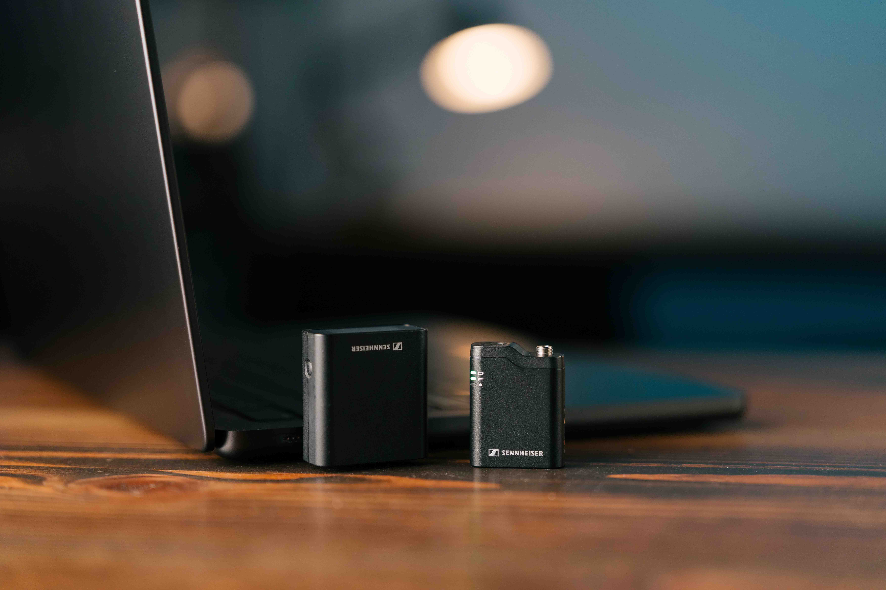 | Profile Wireless 1-channel is also an ideal solution for users looking for a wireless mic for their laptop

Just like the two-channel version, the solo system is quick and easy to set up – no app required. It can be used on cameras, with smartphones and computers, and can be combined with an external lavalier microphone or even used to create a wireless boom. The mic has an operating time of up to seven hours, and 16 GB of memory for up to 30 hours of internal recording.

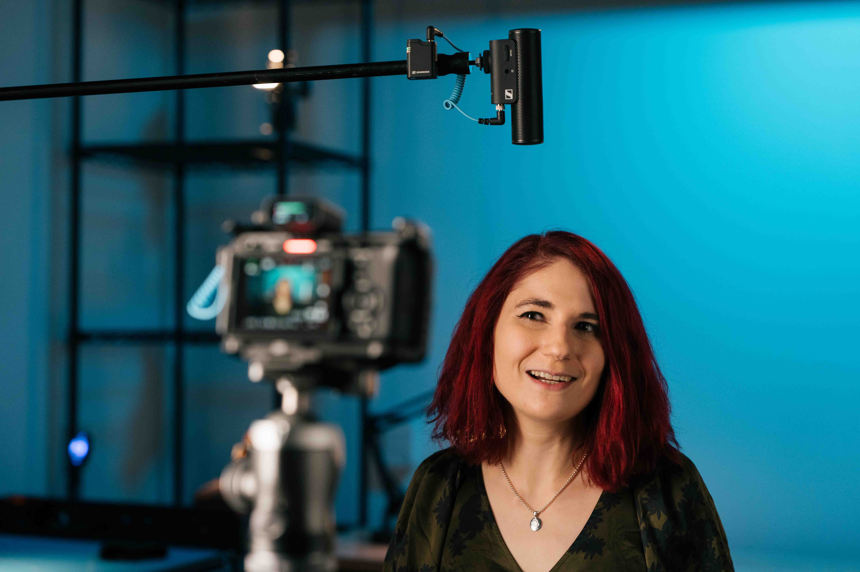 | Profile Wireless can also be used to create a wireless boom, here in combination with an MKE 400 mini-shotgun mic

The Profile Wireless 1-channel mic system comes in a rugged pouch that includes the clip-on microphone with mini windshield and magnetic mount, a two-channel receiver, two USB cables, USB-C and Lightning adapters, a camera cable and a shoe mount adapter. As all Profile Wirelesss components can also be bought separately, nothing stands in the way of expanding the system to two channels at a later point in time.

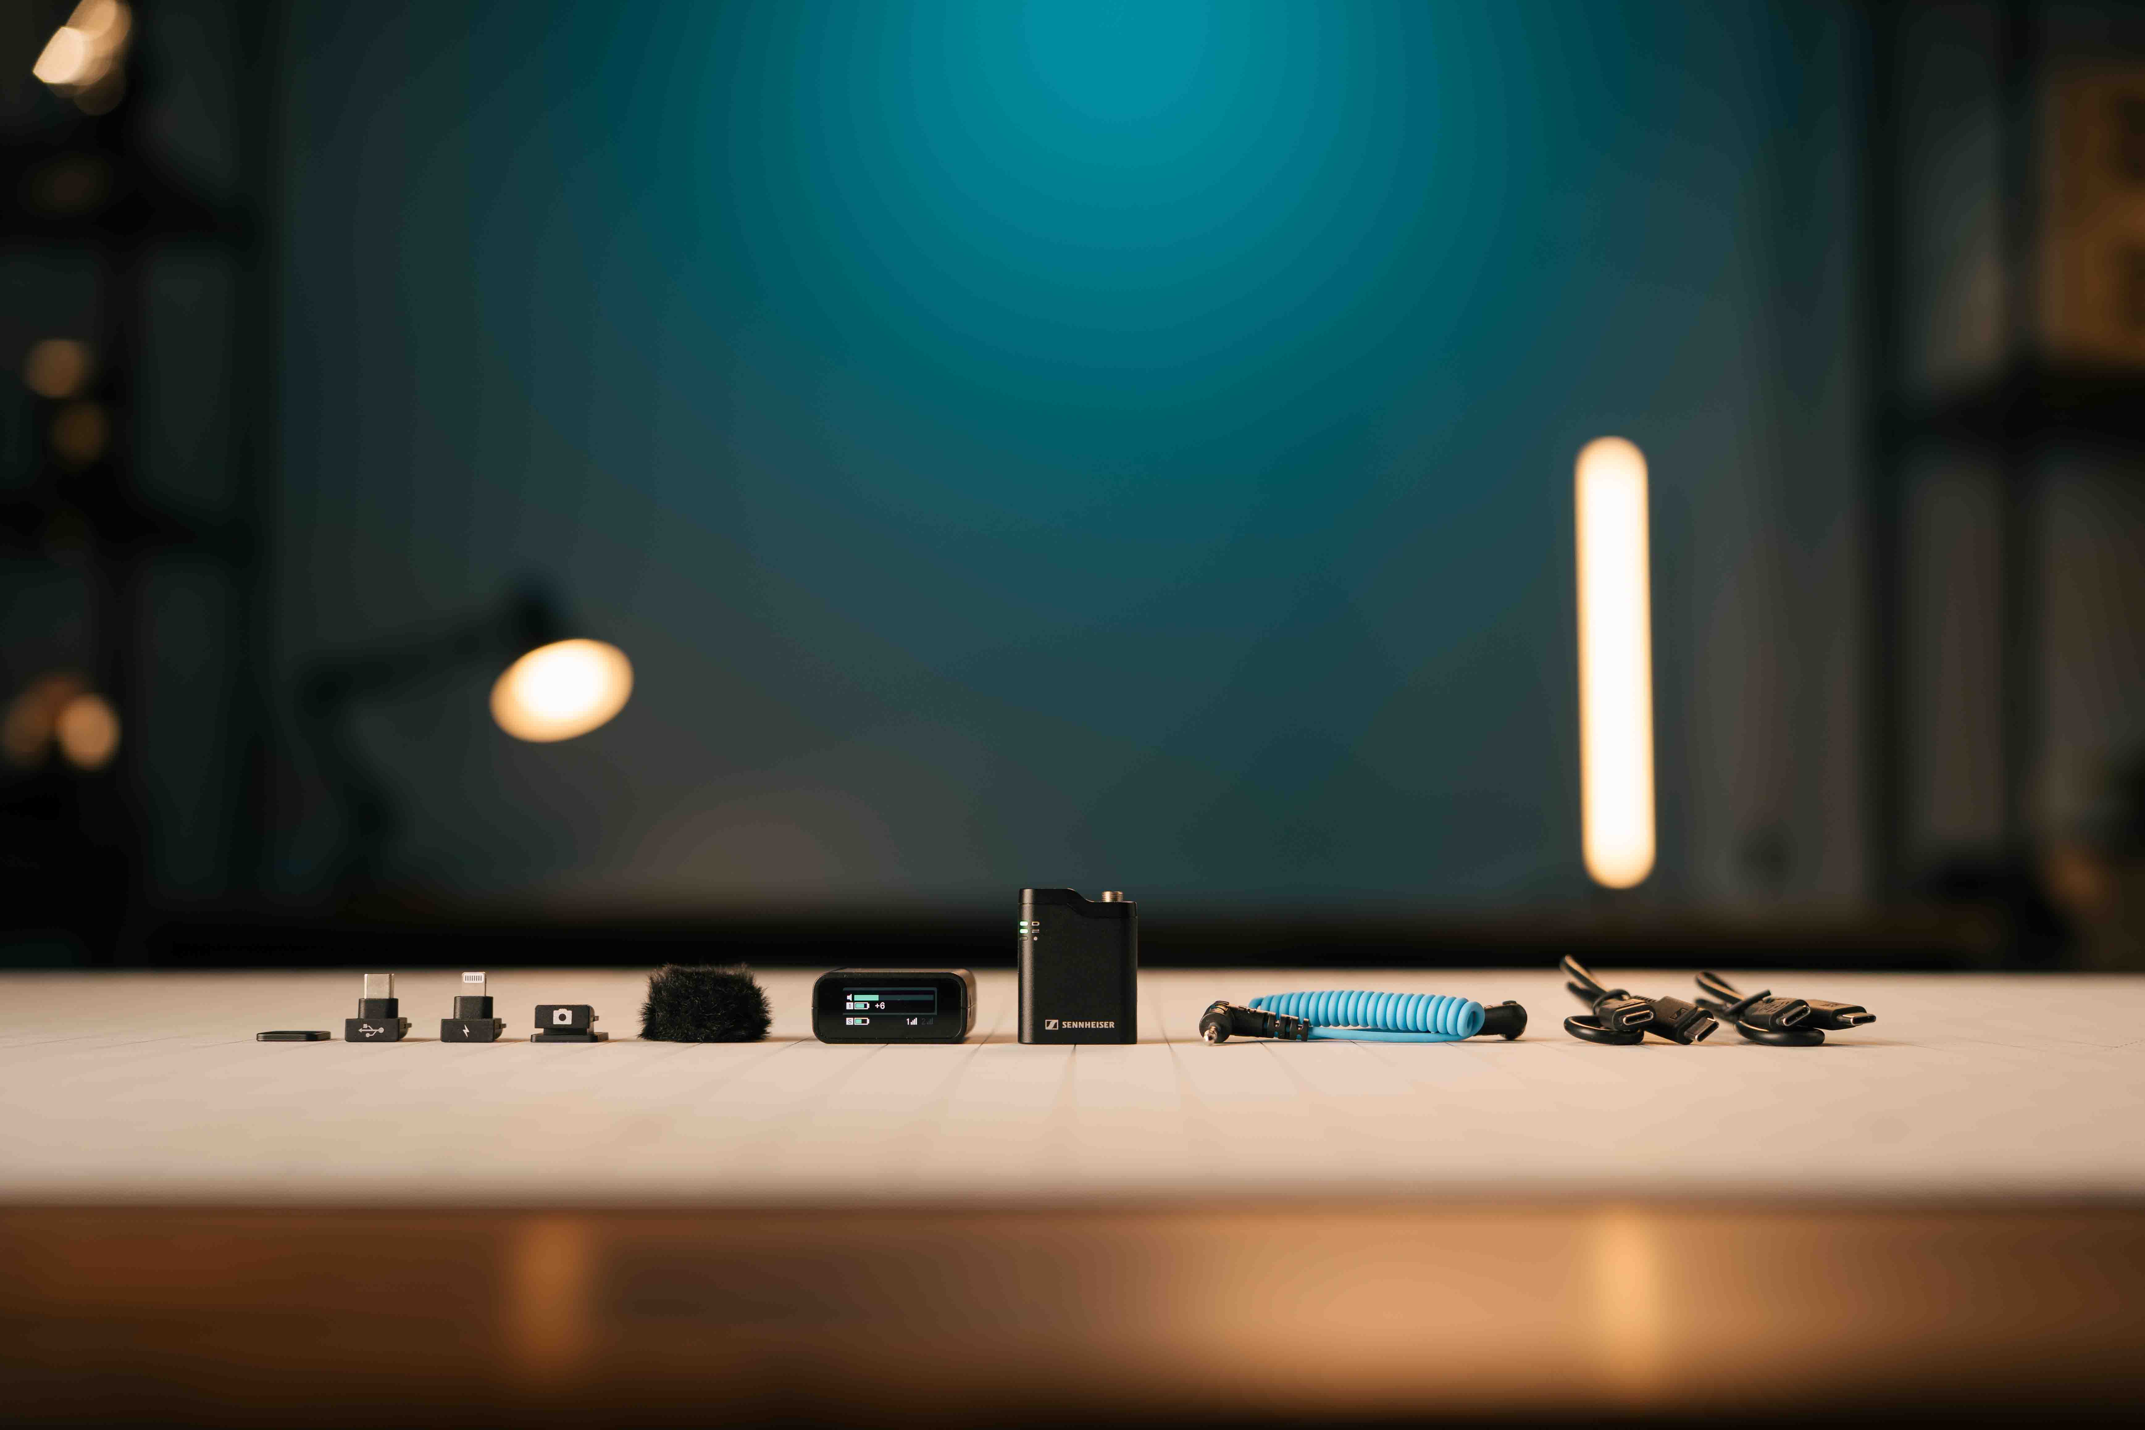

32-bit float update for Profile Wireless
“With the latest Profile Wireless firmware update, we’re addressing user requests for a 32-bit float functionality,” says Millauer. “This will allow creators to record with extremely high dynamic range, and help them to recover clipped audio.”

For 32-bit float recording, Profile Wireless combines the audio signals of the two A/D converters inside the Profile Wireless mics to create a single 32-bit float audio stream.

Creators who prefer 24-bit recording due to its lower memory requirement still have the option to deactivate 32-bit float recording and turn on the Safety Channel Mode. This will output a -6dB version of the audio in addition to the original sound level and thus help protect against clipping.

To update their Profile Wireless system to firmware version V4.1.0, creators are asked to visit www.sennheiser.com/profilewireless. Under Downloads, they will find various firmware updates for Mac and PC, with a smart tool guiding them through the update process for the receiver and transmitter(s). Please note that the first batches of the Profile Wireless 1-channel mic also need to be updated to firmware version V4.1.0.

Millauer concludes, “With the addition of the one-channel system and 32-bit float recording, Profile Wireless becomes the most versatile tool for creators who value excellent sound and see it as a key differentiator for quality content.”

The Profile Wireless 1-channel mic is available from today and retails at EUR 199 (MSRP), USD 199 (MAP), or GBP 169 (MSRP).

(Ends)

The high-resolution images accompanying this media release and additional photos can be downloaded here.

About the Sennheiser brand
We live and breathe audio. We are driven by the passion to create audio solutions that make a difference. Building the future of audio and bringing remarkable sound experiences to our customers – this is what the Sennheiser brand has represented for more than 75 years. While professional audio solutions such as microphones, meeting solutions, streaming technologies and monitoring systems are part of the business of Sennheiser electronic SE & Co. KG, the business with consumer devices such as headphones, soundbars and speech-enhanced hearables is operated by Sonova Holding AG under the license of Sennheiser.

www.sennheiser.com
www.sennheiser-hearing.com

Global Pro Audio Press Contact
Stephanie Schmidt
stephanie.schmidt@sennheiser.com
+49 (5130) 600 – 1275

